1. **Step 6: Create JWTAuthResponse.java DTO**

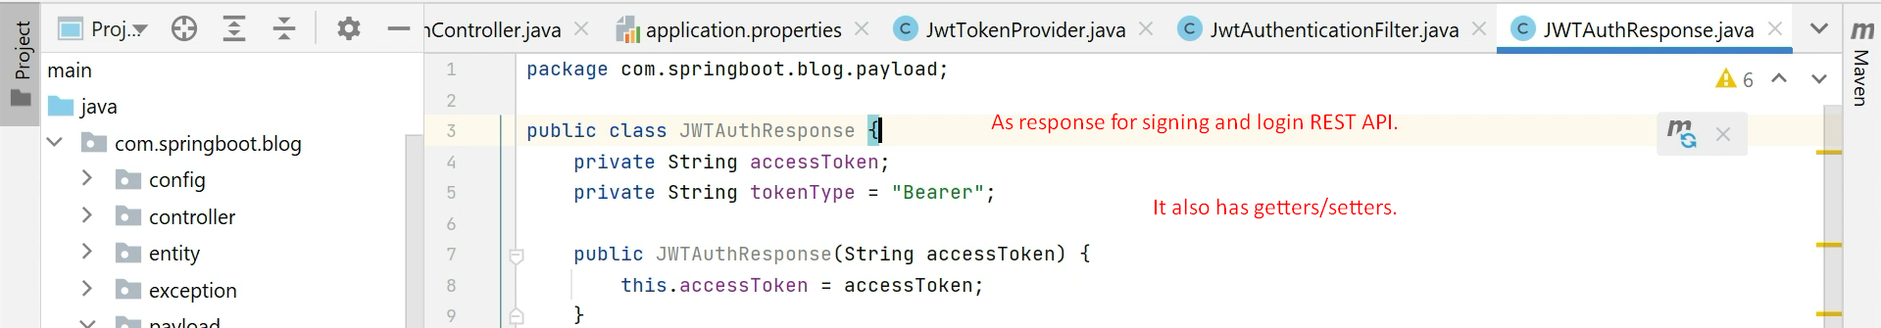

1. **Lecture not completed**